SIMATS ENGINEERING (SAVEETHA SCHOOL OF ENGINEERING)
Department of Computer Science and Engineering

NAME: K. SANJAY FACULTY:Govindaswamy REG.NO: 192511367
COURSE NAME: Compiler Design

- INTEGER TO FLOAT
Code:

#include<stdio.h> int main() {
int a = 10; float b;

b = (float)a;

printf("Integer: %d\n", a); printf("Float: %.2f\n",b);

return 0;
}

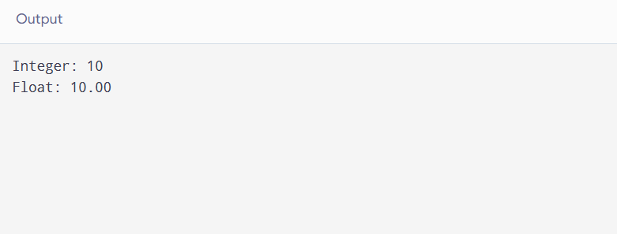
Output:
- FLOAT TO INTEGER
Code:
#include <stdio.h>

int main() {
float a = 10.75; int b;

b = (int)a;

printf("Float: %.2f\n", a); printf("Integer: %d\n", b);

return 0;
}

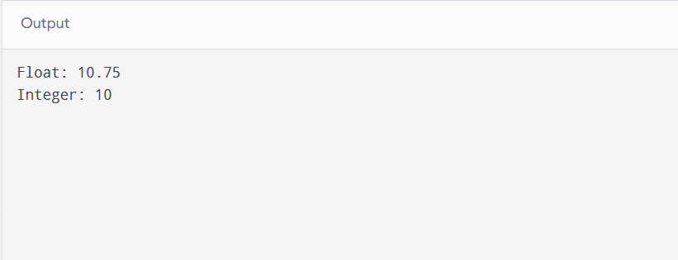
Output:

